Formative Assessment - Global super store Sales Analysis

Here is the dataset of a store, which has branches all over the world. The stakeholders require the detailed report on their sale transaction.

* Perform the basic data cleaning (Score: 2
* Segment the visuals using country, region, market (Score: 1)

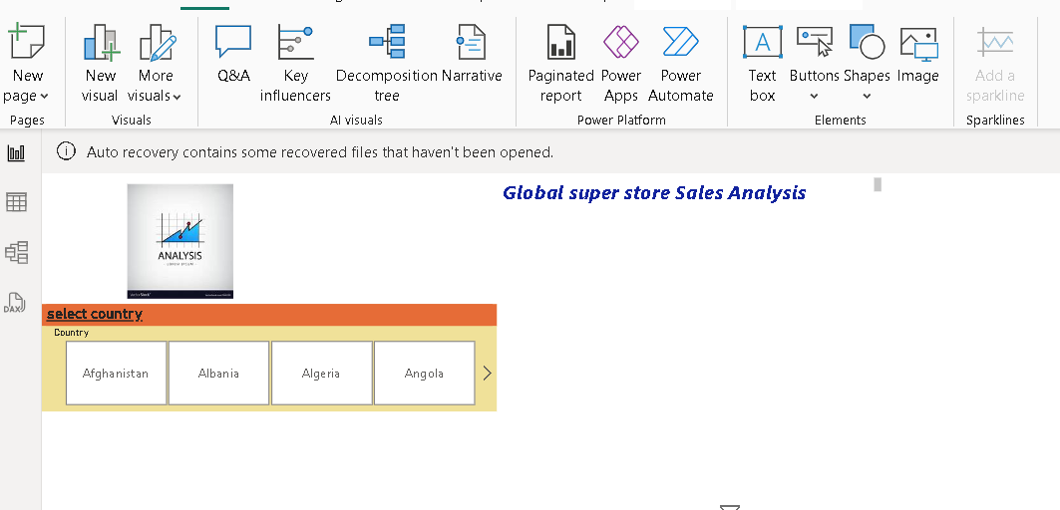

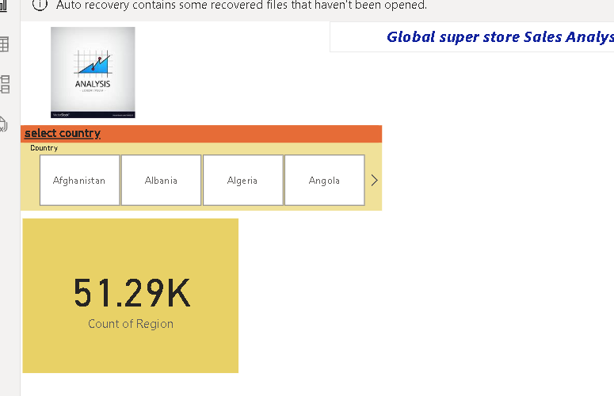

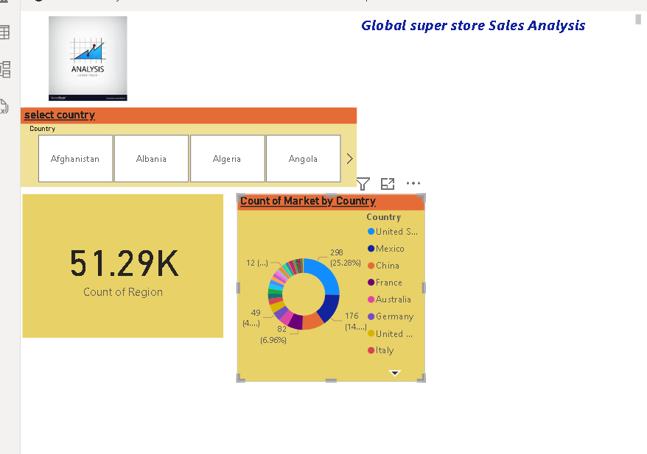

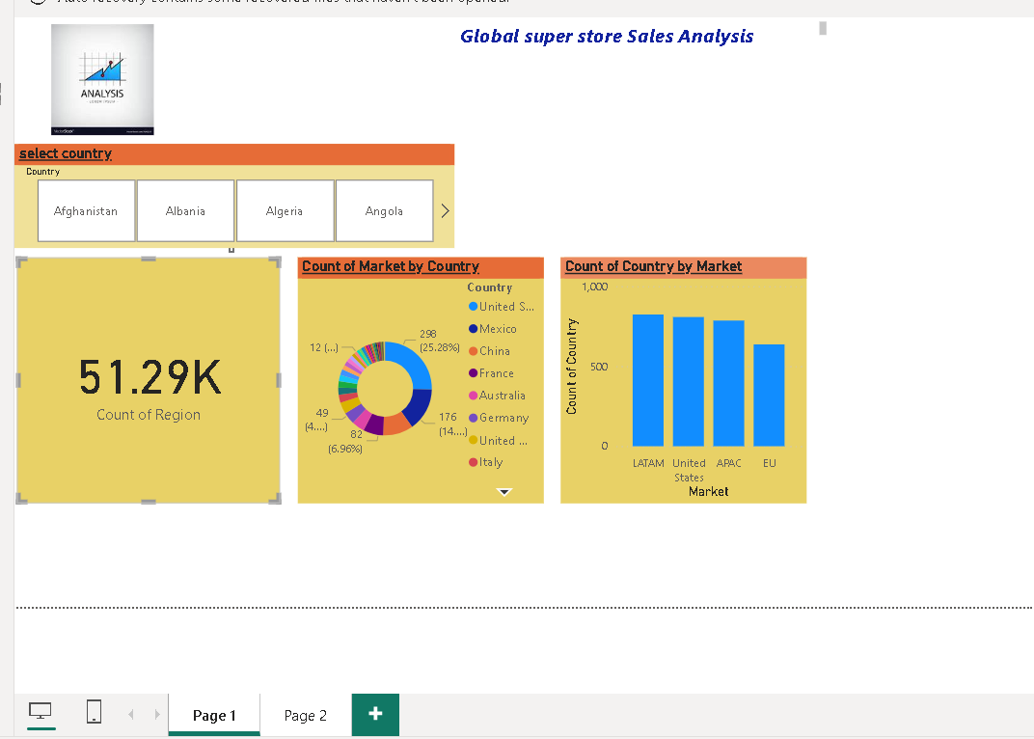

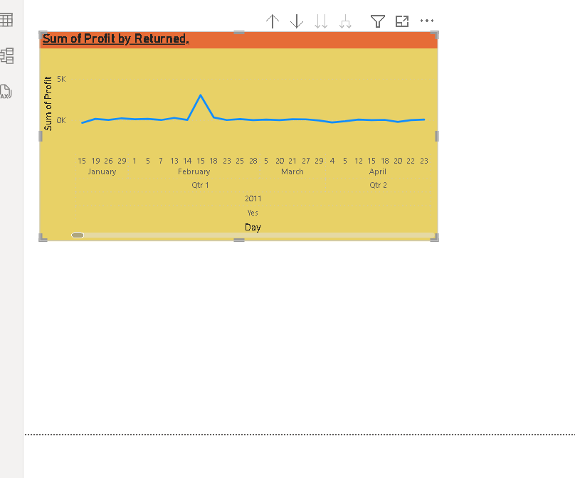

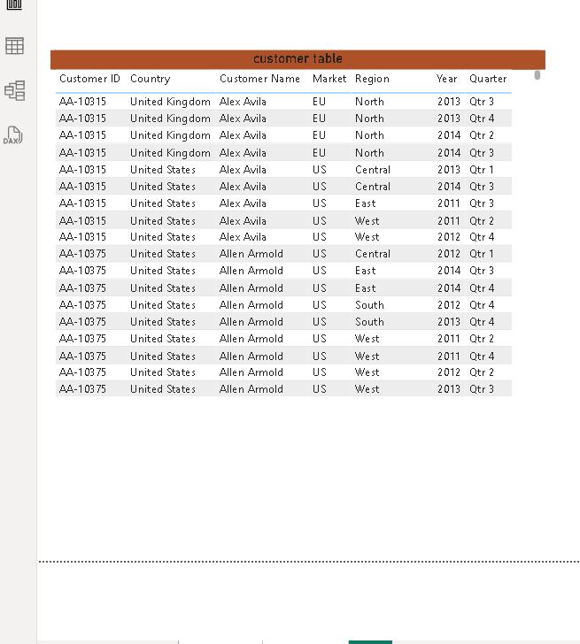

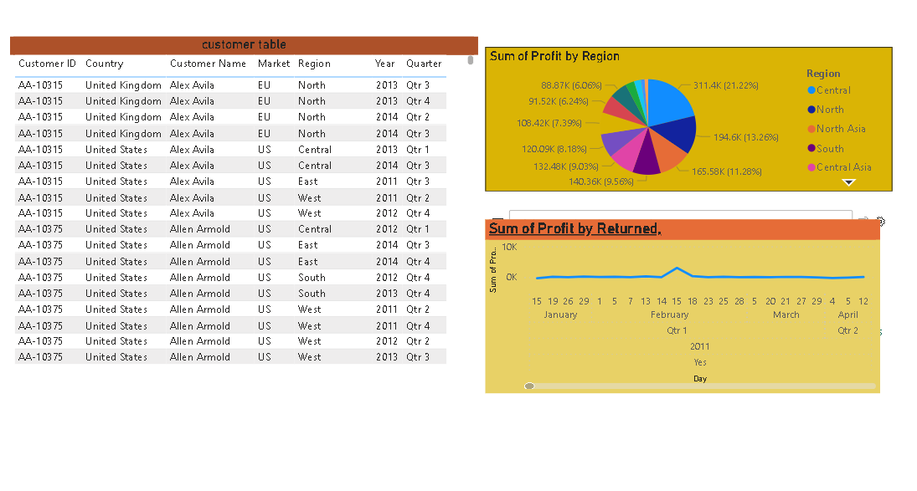



* Analyze the data by visualizing the percentage of shipping based on ship mode.(Score:1)

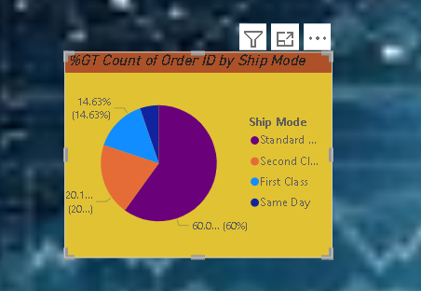

* Give the report to see sales over the city, states, region and market. (Score: 1)

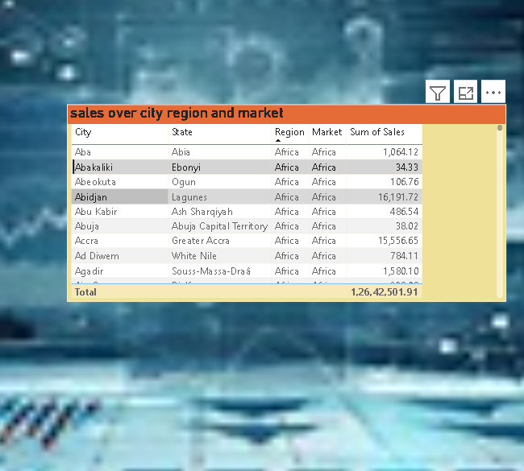

* Create tables for all the visualizations. (Score: 1)

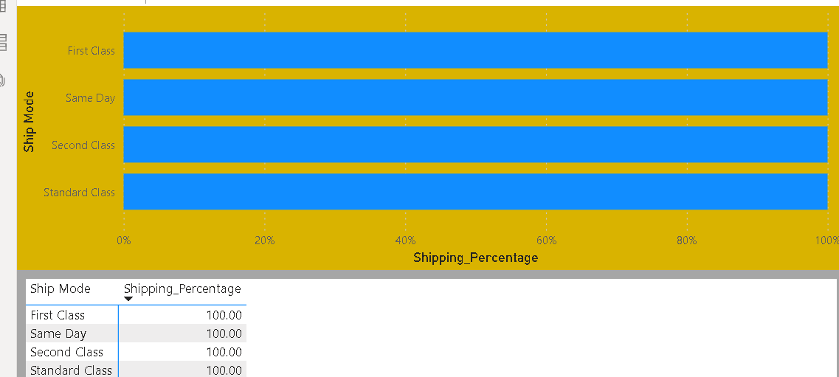

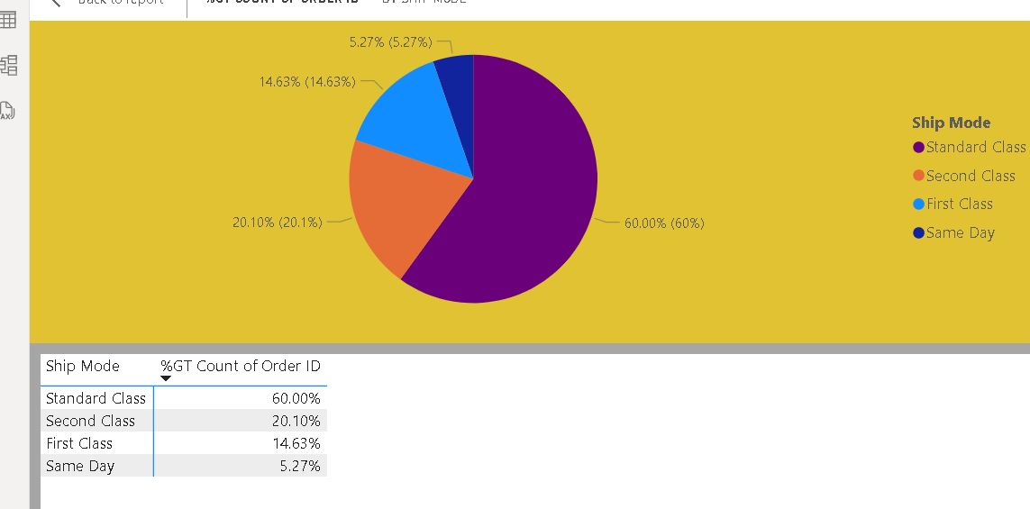

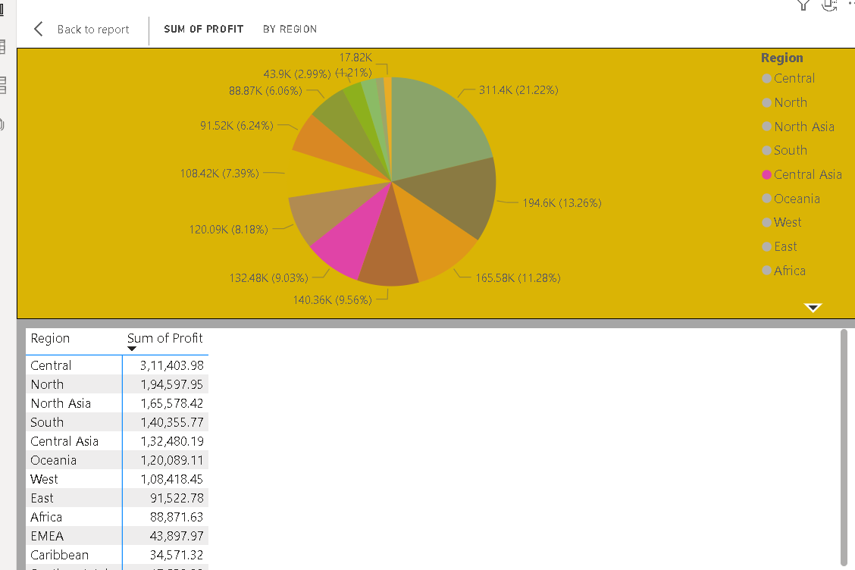

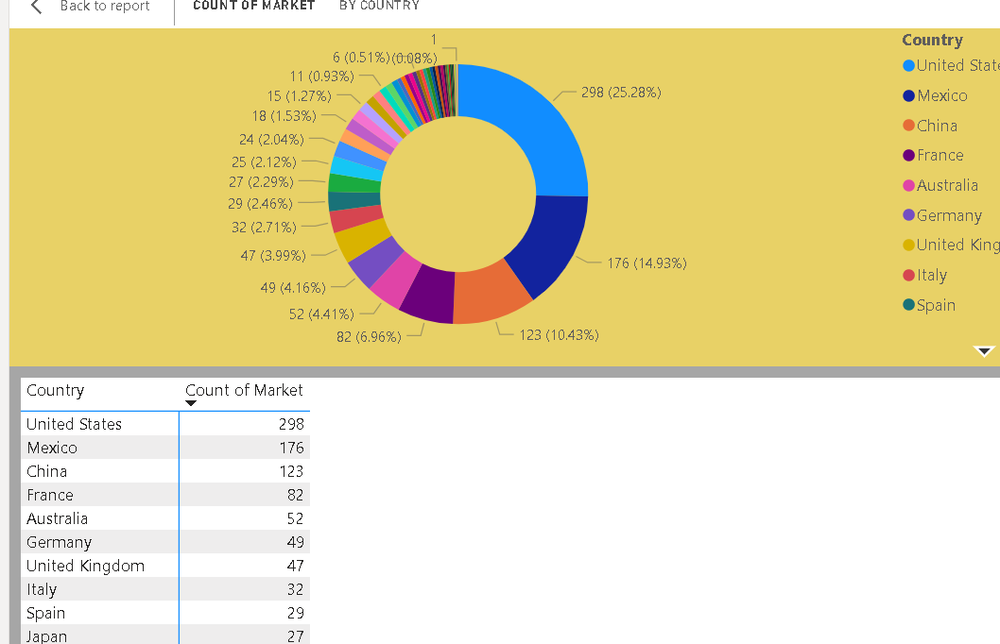

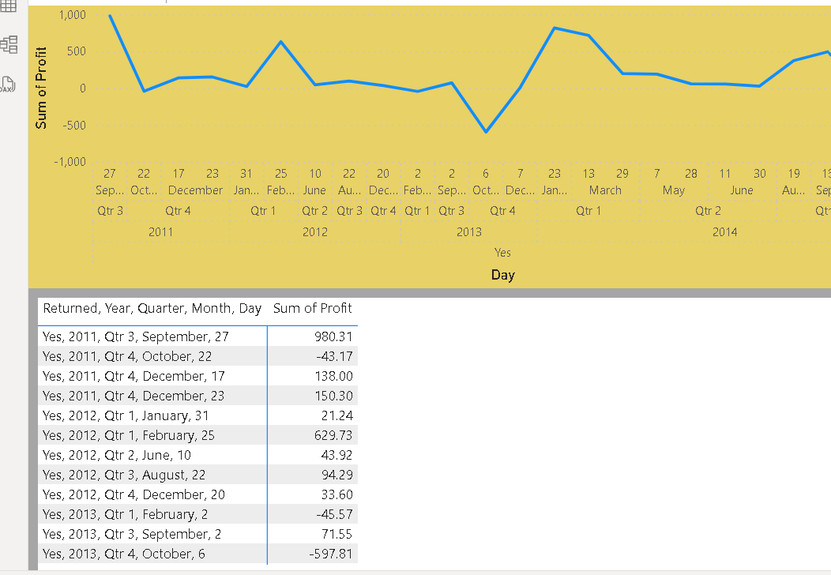

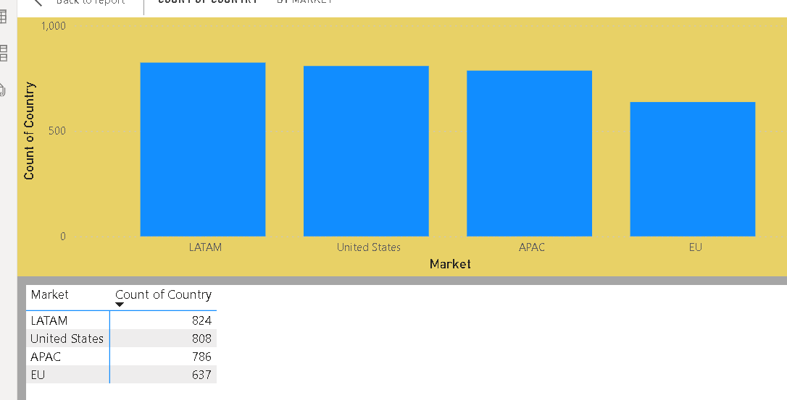

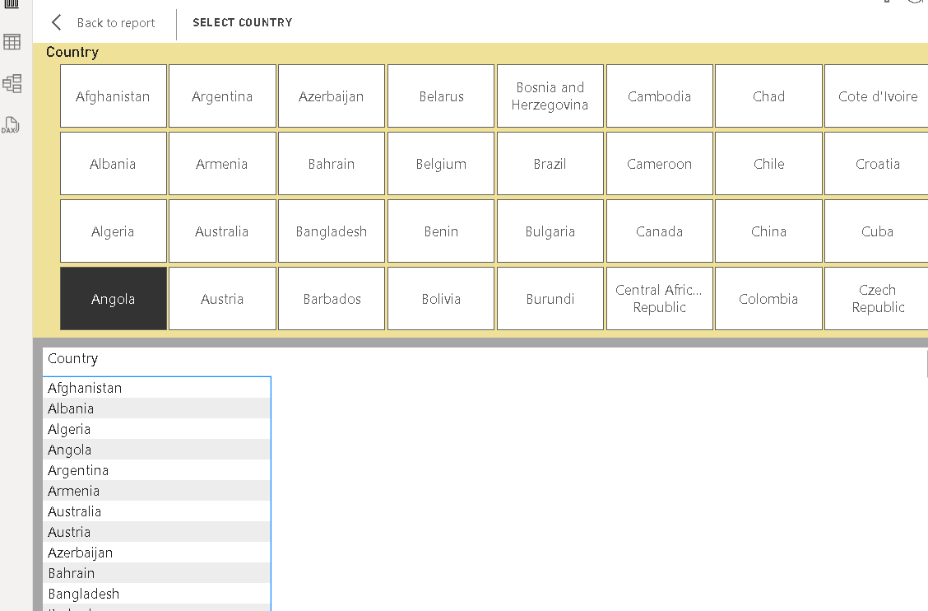

Make these visualizations and create an interactive sales report to show the stakeholders.  
Create a video explaining the visualizations. (Score: 3)  
Timely Submission (Score: 1)  
Total Score : 10  
  
Dataset: <https://docs.google.com/spreadsheets/d/1Ez8RhO1rE2QikfdddOZ19eEZhN4r6eW7WHb9qB05T7E/edit?usp=sharing>